Reducing Age Bias in Machine Learning
An Algorithmic Approach
Adriana Solange Garcia de Alford1, Steven Hayden1,
Nicole Wittlin¹, Amy Atwood²
1 Master of Science in Data Science, Southern Methodist University,
Dallas, TX 75275 USA
2 T-Mobile, 3255 160th Avenue SE,
Bellevue, WA 98008 USA
{sgarciadealford, skhayden, nwittlin}@smu.edu
{steven.hayden, amy.atwood}@t-mobile.com

Abstract. In this paper, we study the prevalence of bias in machine learning; we explore the life cycle phases where bias is potentially introduced into a machine learning model; and lastly, we present how Adversarial Learning can be leveraged to remove unwanted bias and unfair behavior from a machine learning algorithm. This study focuses particularly on the topics of age bias in predicting employee attrition, where the goal is to present a practical approach to of how age bias can be minimized utilizing Adversarial Learning. SENTENCE FOR RESULTS AND CONCLUSION.

1 Introduction
In today’s age of Big Data, data are driving decision-making in almost every field imaginable. At the foundation of this decision-making is a wide range of algorithms churning through endless data to determine if an individual might be a good employee, a worthy loan candidate, a possible repeat criminal, or the university’s next star graduate. But how are these decisions made? What criteria are considered? What if the outcomes are biased?
These algorithmic processes may seem like black box magic, but there are increasing trends to bring the work out of the shadows and assess machine learning for bias and fairness, as well as accuracy and efficiency. In fact, over the last few years, “the majority of the machine learning community is finally publicly acknowledging the prevalence and consequences of bias in machine learning models” \cite{xu_2019}.
Many widely studied and cited examples of bias in machine learning highlight disparity based on race and sex. One of the most frequently noted examples of biased machine learning is COMPAS, a regression model used by judges to predict if a perpetrator was likely to recidivate. The model was proven to double the predicted false positives for recidivism for African American ethnicities than for Caucasian ethnicities \cite{mckenna_2019}. Another example from 2018 was discovered in Amazon’s machine learning model built to evaluate candidate resumes for software engineering roles, where the algorithm explicitly penalized resumes with the word “women’s” and downgraded candidates from two all-women’s colleges \cite{kearns2019ethical}.
Research teams and practitioners have been exploring approaches, techniques, and models to account for and mitigate bias in machine learning in recent years. One intriguing option is the use of adversarial learning. Our team will utilize two competing adversarial models – similar in nature to GANs (generative adversarial networks) \cite{goodfellow2014generative} – to reduce age bias in a sample data set related to a common human resources business problem.
In the domain of human resources, employee attrition garners significant attention. The driving factors of employee attrition have been well studied, and the goal of this work is not to duplicate those efforts. Instead, we seek to explore how age may be influencing employee attrition and whether adversarial learning can reduce bias related to age when predicting if employees will stay or leave a company. The data set we will use is the IBM Employee Attrition, found on Kaggle.
Age, similar to race and sex, is considered a protected class and should not legally be used as an influential factor in many situations, particularly those related to employment and the workplace. Yet, the Equal Employment Opportunity Commission (EEOC) acknowledges that “research on ageist stereotypes demonstrates that most people have specific negative beliefs about aging and that most of those beliefs are inaccurate. These stereotypes often may be applied to older workers, leading to negative evaluations and/or firing, rather than coaching and retraining” \cite{lipnic}.
PLACEHOLDER – for results
PLACEHOLDER – for conclusion
2 Related Research

Overview of Bias in Machine Learning
The concept of bias – and fairness as a related topic – have been studied extensively for decades in philosophy and psychology, well “before computer science started exploring it” \cite{rubenstein2018surveying}. While there is no universal, commonly accepted definition of fairness, bias tends to be a more concrete idea. **ADD RELATIONSHIP OF BIAS AND FAIRNESS HERE … particularly when noting how different preferences, outcomes, and cultural contexts need to be considered. However, at a most basic level, fairness can be broken into “individual fairness,” where similar individuals are treated the same, and “group fairness,” where different groups should be treated equally. Therefore, bias can be defined as a personal and sometimes unreasoned judgement \cite{merriam-webster} that can impede fairness from being achieved. For the purposes of this paper, these definitions are a good starting point.

In the last few years, understanding bias in the context of machine learning has become a more widely discussed topic. One goal in machine learning work is to strive for the highest accuracy possible. But even with good accuracy, has consideration been given to it could impact the populations (or subpopulations) the work is intended to serve or reflect? A well-documented example is COMPAS, which upon further examination was found to double predicted false positives for recidivism for African American ethnicities. The developers did not set out to create a biased system, but it was an unfair and unanticipated outcome.

When defining a question or problem, IBM’s AI Fairness 360 toolkit – an open source software toolkit that can help detect and remove bias in machine learning models – recommends three key questions to consider: what type of fairness is trying to be achieved; what are appropriate tools and metrics depending on the type of fairness and the data; and what algorithms to use \cite{ibm360}.

Simply removing the “protected variable,” say race, gender, or age, from the data will not yield a debiased machine learning model. In fact, because other variables can be highly correlated with the protected variables and serve as proxy data, a model could even amplify bias \cite{lum2016statistical}. It is important to understand where bias may be introduced in the machine learning process and appropriate metrics to measure bias and fairness.

There are three points in the machine learning pipeline where bias can be addressed: during the data collection and preprocessing; during the selection and creation of models; and when implementing results. There are opportunities to intervene at each of these points to mitigate bias. It is recommended that intervention occur as early in the machine learning process as possible, but it will depend on the answers to the questions about fairness and the specific data set \cite{ibm360}.

The IBM AI 360 tool kit offers a good visual to understand the overall process and points for intervention. See figure \ref{fig:RelatedFig}. The first intervention point is during preprocessing. Often this relates to the origin of the data and how it was collected or sampled. For example, groups may be excluded or under represented based on population characteristics. Older generation may utilize social media less than younger adults, so sampling from social media would under sample the older generation compared to the rest of the population. Understanding population distributions and protected groups (or protected attributes) will dictate how to make adjustments, such as resampling or collecting more data, during the preprocessing stage. Preprocessing intervention modifies the training data in an attempt to mitigate bias.
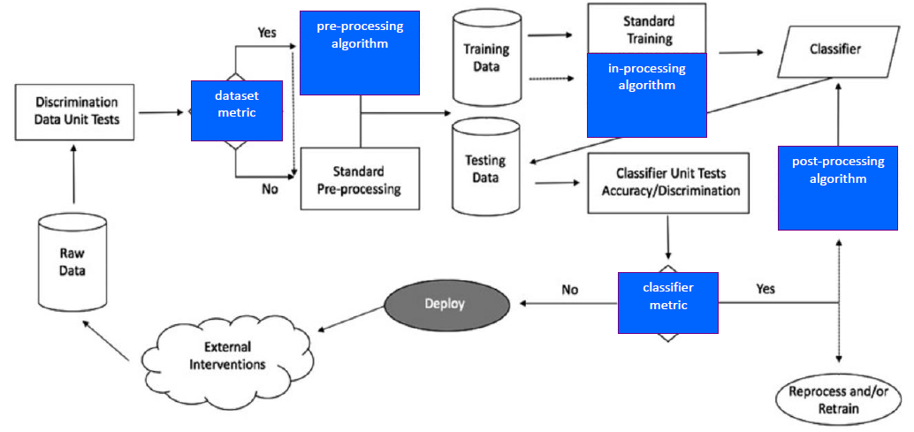
Figure 1. This flowchart depicts three (3) stages in the life cycle of a machine learning model - preprocessing, in-processing and post-processing - where intervention could mitigate bias in the model (from IBM AI Fairness 360 toolkit)

When preprocessing is not an option, it may be necessary to rely on techniques to implement during the machine learning process (known as “in process”). This stage seeks to modify the learning algorithms to remove bias or discrimination during the training process, often by changing the objective function or imposing a new constraint \cite{rubenstein2018surveying}. Of particular interest to this team is the use of adversarial networks, where an adversarial algorithm attempts to remove bias during the training process.

In situations where the machine learning process takes place in a “black box” with no opportunity to intervene in the data or the algorithms, postprocessing techniques can be an option. At this stage, the model training is complete, so a bias mitigation algorithm could be applied to the resulting predicted labels. This intervention would occur before implementation of the model, and the data scientist needs to consider the impact of the results.

Overview of Employee Attrition Research
The topics of employee turnover and factors influencing attrition are well-studied by both the research community and human resources (HR) practitioners. To understand the evolution of the field, Hom, Lee, Shaw, and Hausknecht \cite{hom2017one} conducted a comprehensive and systematic review of the most seminal publications about employee turnover in the Journal of Applied Psychology over the last 100 years. Additionally, they assessed other key theoretical and methodological contributions to the field as part of the review.
Since 2000 and forward, 21st century theory and research has focused on: the idea of embeddedness, or factors and forces influencing attrition; the evolution of the job search process; the influences of employee-organization relationships and HR management systems on collective turnover; the impact of HR practices on good-performers vs bad-performers; and the relationship of collective turnover on organizational performance. The field also saw “significant scholarly attention to employee turnover at the group, team, work unit, and organizational levels” \cite{hom2017one}.
With a basic, foundational understanding of the field of employee attrition, the team turned to exploring common predictors of turnover. Rubenstein, Eblerly, Lee, and Mitchell followed up the comprehensive work of Hom et al. to “assess the progress made in research on voluntary employee turnover” \cite{rubenstein2018surveying}. The aspect of their work that is of most interest to this team is understanding the predictors of employee attrition, especially related to the role of age.
Rubenstein, et all, explored 57 predictors across 1,800 side effects (drawn from a study population of 316 articles). They categorized these specific predictors into several groups: individual attribute predictors (tenure, age, conscientiousness); job aspects (characteristics, security, complexity, as well as traditional characteristics of pay, role ambiguity, role conflict); traditional job attitudes (involvement, satisfaction); newer personal conditions (coping, stress); organizational context (climate, size, prestige); person-context interface (fit, influence, peer/group relations); existing job market (alternatives); attitudinal withdrawal; and employee behavior (absenteeism, performance).
This team also reviewed an article in the SMU Data Science Journal authored by fellow graduate students in April 2018. They conducted an analysis on two distinct data sets to determine the predictors of employee attrition in those two populations. The first data set was anonymized information from the U.S. Office of Personnel Management (OPM), reflecting a full year of separation data from October 2014 and September 2015. Attributes of particular interest in this data set were: age data group, captured categorically in 5-year increments; a lower limit age (lower bound for age); and years to retirement (based on the Federal Employee Retirement system eligibility base of 57 years old). The features of the final model with best prediction accuracy included: lower age limit; length of service; various age bins (age 20-24, 40-44, 45-49, 50-54, or 55-59). They also utilized IBM HR Analytics Employee Attrition & Performance data, a fictional data set created by IBM data scientists, to compare the strongest features of that set with the features selected in the OPM model. Ultimately, the model results were comparable for both sets of data with the relationship between length of service, pay scale, and age being strong predictors; however, the IBM data highlighted nuances missed by the OPM data related to measuring job satisfaction, work-life balance, and engagement. \cite{frye2018employee}
From this background, it is evident that age does play a role in employee attrition; our team seeks to understand impact of this and assess whether or not age bias may be causing undue influence in predicting attrition. The goal of the work described in this paper is not to predict employee attrition, per say, but rather to show how age bias could be reduced through adversarial learning models when attempting to predict attrition.

Understanding the Current Landscape
The urgency of issues surrounding age bias is magnified by understanding today’s employee landscape. In 2018, “the Bureau of Labor Statistics estimated that the oldest segments of the workforce – those ages 65 to 74 and 75 and older – are expected to increase the fastest through 2024. This oldest cohort of workers of age 65+ workers is projected to grow by 75 percent by 2050, while the group of workers age 25 to 54 is only expected to grow by 2 percent over this same period” \cite{lipnic}. The lack of mixed-age teams and reverse-age mentoring, coupled with age stereotypes and bias, can cause varying degrees of tension in the workplace between the generations. Ultimately, our goal is to simulate exploring age bias within the context of employee attrition and demonstrate how an adversarial learning methodology could reduce bias.

3 Understanding Generative Adversarial Networks (GANs)
There have been many techniques, such as Deep Neural Networks, Generative Adversarial Networks (GAN), and Convolutional Neural Network, used to classify images \cite{gu2019improve}. One technique – GAN – stands out in image classification and is the foundation for this paper’s approach to reduce bias. In 2014, Ian Goodfellow and his colleges proposed a new framework to estimate generative models (a model that includes the distribution of the data itself and the likelihood a given example) via an adversarial process, in which two models are trained simultaneously: a generative model G that captures the data distribution, and a discriminative model D that estimates the probability that a sample came from the training data rather than G. \cite{goodfellow2014generative} The adversarial framework makes this classification into a supervised machine learning model, since it knows if the data is real or fake. 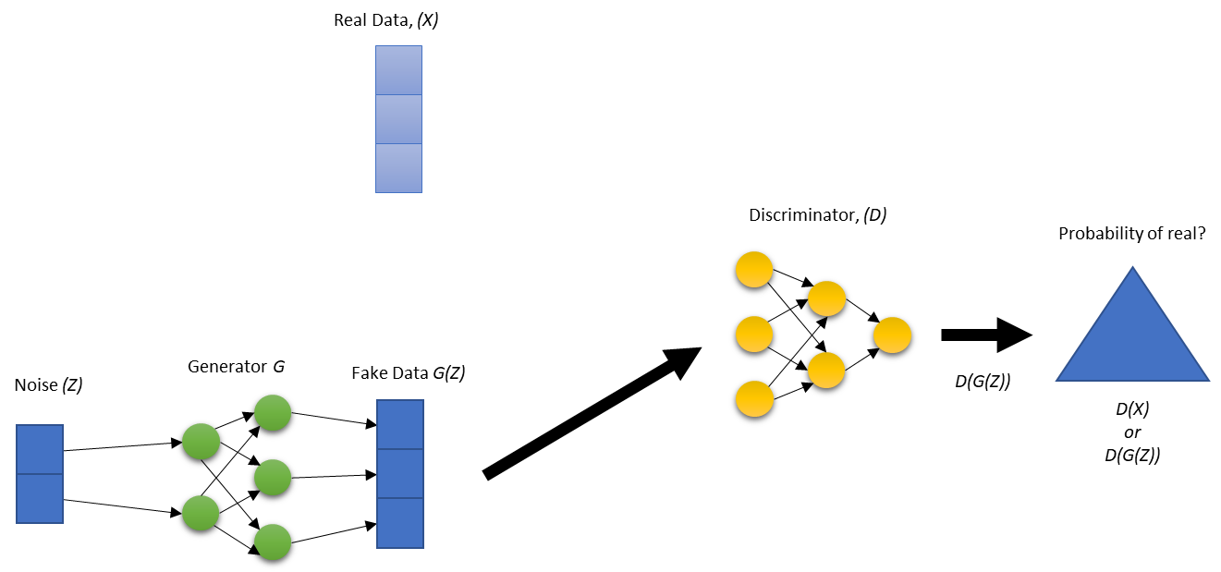Figure 4.1

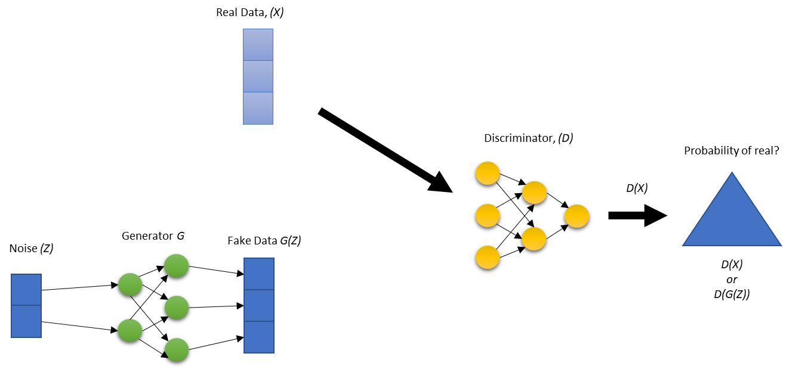 Figure 4.2

Figure \ref{fig:GANs1} and figure \ref{fig:GANs2} illustrate the basic structure of GANs in two steps that happen simultaneously. For explanation purposes, each step is described separately. In figure \ref{fig:GANs1}, the distribution of the real data set is used to generate a fake data set by combining real data and noise, through generator (\emph{G}) algorithm thus, the vector size is the same for both G(\emph{Z}) and Real Data(\emph{X}). Once it is done generating fake data, it passes Fake Data G(\emph{Z}) to the discriminator (\emph{D}). The discriminator (\emph{D}) is a classification algorithm used to determine if the data came from Fake Data G(\emph{Z}) or Real Data(\emph{X}). Figure \ref{fig:GANs2} is the same, but this time the real data (\emph{X}) gets passed to the discriminator (\emph{D}).
The discriminator (\emph{D}) and the generator (\emph{G}) update their parameters iteratively, based on a loss function (explained below) and through back propagation. Back propagation is the process of modifying the parameters (weights) of the network between neurons, so the next iteration is more accurate. If the discriminator (\emph{D}) classified the data correctly as real or fake then the generator (G) gets updated. If the discriminator (\emph{D}) incorrectly classified the data real or fake, then the discriminator (\emph{D}) gets updated.

\begin{equation}
\label{eq:GAN}
V(D,G)=E_{x~P_{data(x)}}[log D(x)]+E_{z~P_{z(z)}}[log(1-D(G(z)))]
\end{equation}
Equation 1 describes the loss function. The first term $E_{x~P_{data(x)}}[log D(x)]$ represents an expected output of the log of discriminator (\emph{G}) when the input is from the real data. The second term $E_{z~P_{z(z)}}[log(1-D(G(z)))]$ is the expected value of the log of the quantity of 1 minus the discriminator (\emph{G}), which is making predictions about the fake samples. This function makes the generator (\emph{G}) want to minimize the G(\emph{Z}) and the discriminator (\emph{D}) maximize it. The conflicting elements of this function make the generator (\emph{G}) seek to maximize G(\emph{Z}) while the discriminator (\emph{D}) works to minimize G(\emph{Z}). This creates the adversarial “game.”
To train the discriminator (\emph{D}), the process loops through the data created by the generator (\emph{G}) and the real data \emph{k} times before the generator (\emph{G}) is updated. This allows the discriminator (\emph{D}) to optimize given \emph{k}, where \emph{k} is a parameter chosen prior to training. GANs use the gradient of the loss function to change the parameters of the discriminator (\emph{D}) to maximize the loss function that sets up the optimization between both models.
Training the generator (\emph{G}) takes noise data and then transforms it to get the fake data for \emph{k} times. This time it allows the generator (\emph{G}) to optimize given \emph{k}. The gradient of the loss function is then used to change the parameters of the generator (\emph{G}) to minimize the loss function. This is a complete iteration of training a GAN model.
Goodfellow also also discussed when to stop training the model. Once the discriminator (\emph{D}) consistently cannot distinguish between fake or real data then training is done. In other words, once the distribution of the generator (\emph{G}) matches the real data. \cite{goodfellow2014generative} The discriminator algorithm can then be implemented in the desired tool for classifying.
4 Data Set: IBM Employee Attrition Data
A best practice in the lifecycle of a machine learning model is to start with exploratory data analysis (EDA), with the objective of extracting information that unveils trends, feature correlation, group distributions, demographics, and biases, among other characteristics. For this paper, the intent is to explore how age impacts the prediction of employee attrition and mitigate any age bias present in the modeling.
From the related research, we knew that age did have an impact on employee attrition. Given the trends noted by the EECO, we anticipate that attrition may increase with age. Additionally, we believe that the attrition rate should be approximately equal across all age groups; therefore, we are looking for evidence that age bias may be occurring more frequently with older employees.

The data set used for this exploration is fictious employee data simulated by IBM data scientists to represent employee attrition and performance \cite{rohan}. There are approximately 1,470 entries representing a specific employee, with 35 descriptive features, where ‘Attrition’ is the dependent, target feature. We are treating ‘Age’ as a protected variable as it should not have undue influence when predicting age.

In the data set, 1,233 employees are classified as “no” with regards to attrition, meaning they remained at the company, and the remaining 237 (with “yes) did leave. This breakdown of 84% remaining vs 16% departing is in line with what we anticipated, and we will be cognizant of the imbalanced distribution as we proceed with the analysis.

Next, we explored attrition across age range, in one-year, five-year and 10-year increments. The five- and 10- year increments are most useful for our purposes. At both ends of the age distribution, there were fewer records (i.e. age 18-19 reflected 17 employees; only five employees were age 60.) Therefore, we combined the youngest employees as 25 and under and the oldest employees as above 50 for analysis purposes. The distribution of employees in this data set generally follow a normal distribution, with a slight right skew toward younger employees, as illustrated in Figure ???. The green segments of the chart indicate the employees that did leave (attrition = yes).

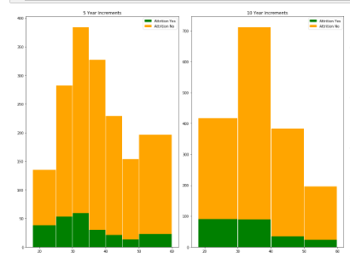
** How can we get the visual clearer?
** Needs caption

Then, we looked at the percentage of attrition by age group in both five-year and 10-year increments. Contrary to our initial thinking, attrition appears to decrease as employees age. **WHY IS THIS IMPORTANT??

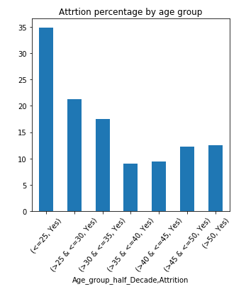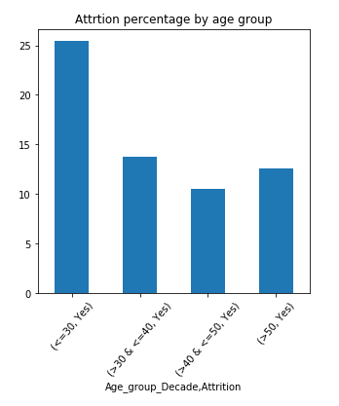

Finally, the team explored a correlation matrix of the data set to understand the relationships between variables, particularly age. In Figure ??, positive correlation is displayed in blue, and negative correlation is displayed in red. We observed that employee age is strongly related to: job level, monthly income, total number of working years, the number of years worked at the company, and number of companies he or she has worked at. A weaker relationship exists between age and educational level, number of years in the current role, number of years since last promotion and number of years with current manager. The correlation matrix also reinforces the inverse relationship between age to attrition seen in the histograms: older employees show lower levels of attrition while young groups demonstrate higher levels. These insights are critical to understand as we conduct further analysis as bias can be amplified through proxy variables that encode similar information to the protected attribute.

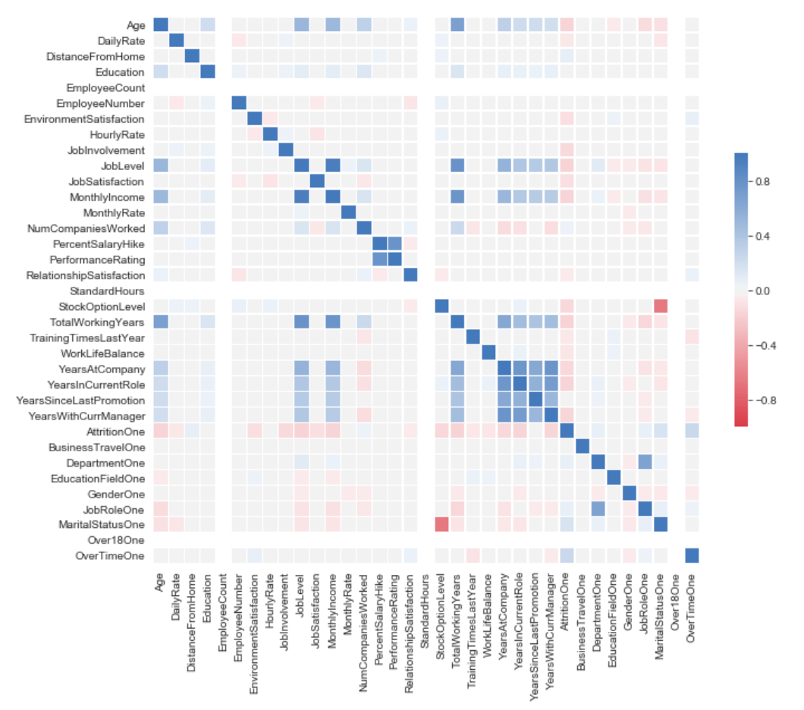

\begin{enumerate}
\item EDA was executed in Python language and libraries.
\item The Python Jupyter notebook is found in the project’s GitHub URL: \url{https://github.com/skhayden/SMU-Capstone-Age-Bias-in-Predictive-Modeling-.git}.
\item Data was extracted in Excel format and converted to CSV format.
\item The data was loaded into a Data Frame to calculate simple statistics for all features.
\item Explored the protected Age feature by finding unique age value counts and producing a bar chart to learn the distribution of the employees ages.
\item Calculated categorical frequency grouping counts to unveil trends and distributions; for example, 1,043 employees out of the 1,470 total employees rarely traveled. This type of frequency groupings is useful to unveil insights and important relationship within the data.
\item As a simplification step, the levels on the ‘Education’ feature were reduced from 5 to 4 by combining levels 4 and 5, since level 5 had a reduced number of employees.
\item The data set was one-hot encoded (and original features were removed) to prepare the data as input to the:
\begin{enumerate}
\item Machine learning model
\item Correlation matrix function
\end{enumerate}
\item A correlation matrix between features is also provided for analysis purposes.
\item A Matplotlib graph chart of the correlation matrix was built for easy visualization.

\end{enumerate}

- Exploration of the protected feature, Age:
  - Found unique age value counts
  - Produced several histograms as visualizations to gain insight on the data:
    - Employee counts around employee’s age
    - Employee counts and percentages by age group:
      - Grouped the data in buckets of 10, 5, and 1 years’ increments
        - In some of the histograms and due to a reduced number of employees in certain groups, we combined these data with their closest age group:
          - Employees of age less than 20 were combined with the 20 years of age group.
          - Employees of age 50 and above were combined with the 50 years of age group.

******DRAFT 1 Ends Here******
5 Experiment
The anticipated outcome of this study is to demonstrate that age bias can be removed from a model based on stochastic gradient decent type model with adversarial learning. The design of our analysis is built on two scenarios. Scenario one is our baseline logistic regression model trained and tested on the IBM employee data set, where the resulting accuracy of predictions are measured across the five- and 10-year age increments. Scenario two will use adversarial learning to mitigate bias resulting from age to predict attrition, where the desired outcome is strong accuracy and demographic parity. The parity metrics reveal some statistical measure across groups, and demographic parity is where the proportion of both protected unprotected classes receive a positive outcome at equal rates. Both scenarios will split the IBM data with an 80\% training set/20\% test set, a common standard for machine learning. Under both scenarios, the algorithms will be trained using gradient descent; this is especially critical for adversarial learning in scenario two when the algorithms are trained in tandem.

To design scenario two, we turned to the work of Zhang, Lemoine, and Mitchell that demonstrates how the principles of GANs can setup two competing models with the goal to mitigate bias. The advantages of this approach are that: it can be used to enforce demographic parity, equality of odds, or equality of opportunity, which each seek to achieve a different definition of fairness; output variables and/or protected variables can be discrete or continuous; the model can be employed with both simple or complex predictions provided it is trained using gradient-based methodology; and it achieves optimality when the predictor converges to a model that satisfies the desired fairness \cite{zhang2018mitigating}.

Adversarial learning to mitigate bias starts with a model to predict \emph{Y} given explanatory variables \emph{X}. This part of the model is similar to the generator(\emph{G}) illustrated above in the GAN overview. The negative of the gradient of the weights $\bigtriangledown_W$ is passed to the adversary model. The adversary model predicts the protected variable \emph{Z} given only \emph{Y_hat}. This architecture with the adversary receiving Y_hat is specifically related to demographic parity. The adversary model is similar to the discriminator(\emph{D}) \cite{zhang2018mitigating}.

\begin{equation}
\bigtriangledown_W L_P - proj_{\bigtriangledown_W L_A} \bigtriangledown_W L_P - \alpha \bigtriangledown_W L_A
\label{eq:AdvLoss}
\end{equation}

The equation \ref{eq:AdvLoss} is how the weights should be updated according to the loss functions. It is what sets up the adversary feedback between the two models. The first term $\bigtriangledown_W L_P$ is the gradient of weights of the loss for predictor. “The middle term $proj_{\bigtriangledown_W L_A} \bigtriangledown_W L_P$ prevents the predictor from moving in a direction that helps the adversary decrease its loss” \cite{zhang2018mitigating} The last term $\alpha \bigtriangledown_W L_A$ is much like the maximization side of the loss function of the discriminator(\emph{D}).

The prediction accuracy is then measured by age groups that were created in the initial data exploration to get base reading on bias in the age groups. The adversarial and prediction algorithms can then be trained to measure the accuracy between the age groups to compare the bias between the two methods. The anticipated improvement from the baseline model to the model resulting from adversarial learning will demonstrate that the age bias in the IBM data has been mitigated.
The neural nets created for this experiment were intentionally left shallow for simplicity. The predictor has two hidden layers with 25 and 50 nodes respectively using Relu for the activation function. The output layer uses a sigmoid activation for a logistic regression to do binary classification. A binary_crossentropy loss function is selected to train the predictor and calculated the gradients to update the weights. The adversarial has one hidden layer with 25 nodes using Relu as its activation function. The output layer uses a liner activation as it is trying to predicate age. Both models are wrapped together with a singular loss function \ref{eq:AdvLoss2} that is a modified mean squared error designed to maximize the loss for the advisories.

6 Results

As described above, we designed the architecture of our models to be able to measure the change in demographic parity from the baseline model to the model after implementing the GANs structure. From these two resulting models, we calculate standard metrics to evaluate performance, as well as several specifically related to group fairness.

First, we evaluate accuracy and would like our models to show relatively equally accuracy across all of the age groups. Initially, we anticipated lower accuracy in higher age groups given the distribution of our data. However, the results of our baseline model show the opposite of our expected results. Age groups less than 35 have a lower accuracy than age groups between 35 and 45. We then see a decrease in accuracy in our older population (>50). We attribute this trend to the larger population in the middle age ranges and the lower attrition in the older age group. However, accuracy across all the age groups was above 75% (ranging from 75% to 95%), and the overall model accuracy was nearly 86%. We feel this is a good baseline from which to work.

For comparison, we looked at accuracy by age group after employing the GAN architecture. It is known that limiting models with fairness constraints – such as the variables the adversary model can access – will decrease accuracy. As expected, we did see decreases in accuracy in most age categories. While the overall model did not see a significant decrease in accuracy – down to 83% - the range of accuracy across age groups shifted lower to between 70% and 91%. Table ?? summarizes the changes in accuracy.

ACCURACY | <= 25 | (25, 30] | (30, 35] | (35, 40] | (40, 45] | (45, 50] | > 50 | OVERALL
Baseline/Pre-Gan | 0.7576 | 0.8400 | 0.8315 | 0.9138 | 0.9464 | 0.8696 | 0.7941 | 0.8587
Post-Gan | 0.6970 | 0.800 | 0.8314 | 0.8966 | 0.8929 | 0.9130 | 0.7941 | 0.8315

In addition to accuracy, we looked at several group fairness metrics that require parity of some statistical measures across groups. It is important to note that most fairness metrics are considered between the “protected” and “unprotected” groups. Since our experiment does not have a “protected” group per se, we considered the values of fairness metrics in comparison across each age group. Ultimately, our goal is to have demographic parity in our final model, which is achieved when each group has equal likelihood to be assigned a positive outcome. Stated another way, demographic parity means the positive predictions in subgroups are close to each other (both true positive and false positive predictions of the model).

DEMOGRAPHICH / PROPORTIONAL PARITY | <= 25 | (25, 30] | (30, 35] | (35, 40] | (40, 45] | (45, 50] | > 50 | OVERALL
Baseline/Pre-Gan | 0.9394 | 0.9600 | 0.9438 | 0.9655 | 0.9464 | 0.9565 | 1.000 | 0.9375
Post-Gan | 1.000 | 1.000 | 0.9888 | 0.9828 | 1.0000 | 1.000 | 1.000 | 0.9973

To assess demographic parity equitably between groups, we calculated it as a proportion of the size of each group. Both are achieved if the proportion of positive predictions in the subgroups are close to each other. Our results related to these metrics for the baseline model range between 94% and 100%, which would indicate our baseline has good parity across the age groups. For the second GAN model, the range demographic parity is 98% to 100%, an improvement over the baseline model. See Table ??. Given these results, we believe that our objective to reduce age bias in our data set to classify attrition of employees was achieved.

We acknowledge the limitations of demographic parity since it only considers positive predictions and does not take into account all aspects the results found in a confusion matrix. It can make an otherwise accurate classifier unfair due to limiting the assessment to positive predictions, and also may treat similar individuals differently merely because they belong to different groups \cite{algofairness}.

We did not design our adversarial model with equality of odds or equality of opportunity in mind, but we can still calculate those metrics from our baseline and GAN model confusion matrices for each group to see what impact the adversarial architecture had with regard to other aspects of fairness. A full summary of the confusion matrices for each age group can be found in the Appendix. Equality of odds looks at both the true positive rate (TPR) and the false positive rate (FPR) for each group as comparison \cite{fairnessdefs}. While the baseline model may not meet the equality of odds criteria since the false positive rate for the 40-45 age group is significantly lower, the second post-GAN model shows strong results across each age group for both true positive rates and false positive rates. Our second model satisfies the equality of odds.

EQUALITY OF ODDS |  | <= 25 | (25, 30] | (30, 35] | (35, 40] | (40, 45] | (45, 50] | > 50 | OVERALL
Baseline/Pre-Gan | TPR | 1.0000 | 1.0000 | 0.9726 | 0.9811 | 1.0000 | 0.9524 | 1.0000 | 0.9772
 | FPR | 0.8 | 0.8 | 0.8125 | 0.8 | 0.5 | 1 | 1 | 0.7377
Post-GAN | TPR | 1.0000 | 1.0000 | 1.0000 | 0.9811 | 1.0000 | 1.0000 | 1.0000 | 0.9967
 | FPR | 1 | 1 | 0.9375 | 1 | 1 | 1 | 1 | 1

A less stringent measure of equality of odds is equality opportunity, which only considers the true positive rate \cite{fairnesscomps}. Since equalized odds implies equal opportunity our both our models satisfy this metric. The second post-GAN model shows stronger equality of odds than our baseline.

DELETE - NOTE:

Algo Fairness Citation
@misc{pessach2020algorithmic,
title={Algorithmic Fairness},
author={Dana Pessach and Erez Shmueli},
year={2020},
eprint={2001.09784},
archivePrefix={arXiv},
primaryClass={cs.CY}
}

Fairness Defs Citation

@INPROCEEDINGS{8452913, author={S. {Verma} and J. {Rubin}}, booktitle={2018 IEEE/ACM International Workshop on Software Fairness (FairWare)}, title={Fairness Definitions Explained}, year={2018}, volume={}, number={}, pages={1-7},}
Fairness Comps Citation
@misc{garg2020fairness,
title={Fairness Metrics: A Comparative Analysis},
author={Pratyush Garg and John Villasenor and Virginia Foggo},
year={2020},
eprint={2001.07864},
archivePrefix={arXiv},
primaryClass={cs.CY}
}
7 Ethics
Ethics
Ethics are a complex topic in any field, and scenarios related to bias, fairness, and ethics in both machine learning and the workplace should not be taken lightly. Our experiment to use adversarial nets works to mitigate possible age bias led us through a critical thinking process about sources of data bias, aspects of fairness related to people, systems, and outcomes, and the decisions to be made as a result of the process. Many resources exist to dig into these questions in detail; our goal is to summarize our thinking process and pose critical, high-level questions to spur more critical consideration of bias and fairness.

First, it is important to understand the sources of bias in data. Data used for training machine learning processes may encode biased human decisions, encapsulate systemic issues related to different groups of people or society, or reflect outdated perspectives. Missing data or sample/selection bias may result in systems that do not represent the target population. While data analysis often will specifically exclude “sensitive” or protected variables such as age, race, or gender, this information can be encoded as “proxy” attributes which may influence the machine learning process unintentionally. Finally, bias can result from algorithmic objectives that unfairly favor or disadvantage certain groups. \cite{algofairness} Cathy O’Neil notes “big data processes codify the past. They do not invest in the future. Doing that requires mortal imagination, and that’s something that only humans can provide. We have to explicitly embed better values into our algorithms, creating Big Data models that follow our ethical lead” \cite{oneil}. With this call to action, we directed our attention to bias in algorithmic and defining an appropriate definition of fairness we were trying to achieve.

As a starting point, it is important to understand fairness falls into two general categories: disparate treatment and disparate impact. Disparate treatment is intentional mistreatment based on a particular attribute. Considered to be direct discrimination, there are legal systems in place to prevent this kind of treatment, and US Civil Rights Act of 1964 clearly articulates attributes or classes considered protected, such as race, color, sex, age, marital status, religion, disability, national origin, among others. Leaving these protected attributes out of a modeling process will likely prevent disparate treatment or discrimination; however, unintentional disparate impact or unintentional discrimination may negatively affect a protected class, even if seemingly neutral policies are in place. We acknowledge that age is a sensitive attribute, and it is also known to influence employee attrition. Therefore, we were mindful of indirect discrimination in our process.

Next, we considered what groups the machine learning process will impact or is intended to serve. This helps determine the type of fairness trying to be achieved, as well as illuminate fairness metrics to be considered. As noted in the introduction, a process may seek to achieve fairness among groups or subgroups, or individuals, or some combination of both. The Center for Data Science and Public Policy at The University of Chicago has developed Aequitas, an open source bias audit toolkit, to assist in determining the type of fairness trying to be achieved. For us, the “Fairness Tree” [CITE UC site] was helpful in determining the type of group fairness – demographic parity – that was appropriate to our problem. Overall, the decision tree encourages practitioners to consider the following questions related to fairness: should fairness be based on representation or on the errors of a system; are people to be selected by specific numbers or by proportion of population; is the machine learning process meant to intervene in a punitive or assistive capacity; is the intervention intended for most people related to the process or a small fraction; and is the impact intended for everyone without regard to actual need or outcome, or some other subset related to intervention or need? The tree then defines the fairness metrics to consider in designing a machine learning process.

There are many articles that define fairness criteria mathematically and illustrate how to design machine learning process that attempt to achieve these differing aspects of fairness. While understanding these details is critical, it is beyond the scope to summarize our critical thinking about bias and fairness in designing the adversarial machine learning process we used. There are many open source tools and toolkits (IBM’s AI Fairness 360 Open Source Toolkit, the Aequitas toolkit), software packages (fairness R package), and books (The Ethical Algorithm, https://fairmlbook.org/) to serve as references. These were extremely useful to us in designing our technical machine learning architecture, but also prompted good discussions we considered how to create an unbiased and fair system.

Looking ahead, there is great opportunity embrace fairness and unbiased processes within machine learning. \cite{asurvey} notes three aspects the machine learning community can continue to research and explore:
- Synthesizing a definition of fairness. Our own experience revealed many different definitions of fairness, often with slight nuances of difference between seemingly similar concepts. While we were able to achieve the definition of fairness we set out to achieve, it is unclear how this would fare in a difference use case or related to a different definition of fairness. \cite{asurvey} notes this as an open research problem.
- Searching for Unfairness. \cite{asurvey} states that “given a definition of fairness, it should be possible to identify instances of this unfairness in a particular dataset.” For us, this concept is not necessarily relevant to our dataset, but presents an interesting thought process. Is it possible to extract elements of unfairness in data or in a system, rather than approaching the design of a system a fairness objective? Are there processes that could remove unfairness akin to how a surgeon removes a tumor?
- From Equality to Equity. Most of the literature we reviewed to learn about bias and fairness focused on equality, which can be defined as “ensuring that each individual or group is given the same amount of resources, attention or outcome” \cite{asurvey}. Considering how to move from equality to equity – where individuals or groups have the resources they need to succeed – is a timely and relevant topic, both for machine learning and for society as a whole. We are hopeful that society will evolve to be more equitable, and with foresight, the machine learning community can help lead the design of systems that support and encourage this.

Citation for Aequitas – how do we do websites??

http://www.datasciencepublicpolicy.org/projects/aequitas/

Citation for A Survey
@misc{mehrabi2019survey,
title={A Survey on Bias and Fairness in Machine Learning},
author={Ninareh Mehrabi and Fred Morstatter and Nripsuta Saxena and Kristina Lerman and Aram Galstyan},
year={2019},
eprint={1908.09635},
archivePrefix={arXiv},
primaryClass={cs.LG}
}

8 Conclusions
Future Work
APPENDIX

\begin{appendices}

\chapter{Appendix A:}

\begin{table}[]
\begin{tabular}{cllllllllllllllll}
\cline{2-7}
\multicolumn{1}{l|}{} & \multicolumn{2}{c|}{\textbf{\textless{}= 25}} & \multicolumn{2}{c|}{\textbf{(25, 30{]}}} & \multicolumn{2}{c|}{\textbf{(30, 35{]}}} & \multicolumn{2}{c}{\textbf{}} & \multicolumn{2}{c}{\textbf{}} & \multicolumn{2}{c}{\textbf{}} & \multicolumn{2}{c}{\textbf{}} & \multicolumn{2}{c}{\textbf{}} \\ \cline{2-7}
\multicolumn{1}{l|}{} & \textit{\textbf{PreGan}} & \multicolumn{1}{l|}{\textit{\textbf{PostGan}}} & \textit{\textbf{PreGan}} & \multicolumn{1}{l|}{\textit{\textbf{PostGan}}} & \textit{\textbf{PreGan}} & \multicolumn{1}{l|}{\textit{\textbf{PostGan}}} & \textit{\textbf{}} & \textit{\textbf{}} & \textit{\textbf{}} & \textit{\textbf{}} & \textit{\textbf{}} & \textit{\textbf{}} & \textit{\textbf{}} & \textit{\textbf{}} & \textit{\textbf{}} & \textit{\textbf{}} \\ \cline{1-1}
\multicolumn{1}{|c|}{\textbf{Accuracy}} & 0.757576 & \multicolumn{1}{l|}{0.69697} & 0.84 & \multicolumn{1}{l|}{0.8} & 0.831461 & \multicolumn{1}{l|}{0.831461} & & & & & & & & & & \\
\multicolumn{1}{|c|}{\textbf{Demographic / Proportional Parity}} & 0.939394 & \multicolumn{1}{l|}{1} & 0.96 & \multicolumn{1}{l|}{1} & 0.94382 & \multicolumn{1}{l|}{0.988764} & & & & & & & & & & \\
\multicolumn{1}{|c|}{\textbf{Positive Predicted Value}} & 0.741935 & \multicolumn{1}{l|}{0.69697} & 0.833333 & \multicolumn{1}{l|}{0.8} & 0.845238 & \multicolumn{1}{l|}{0.829545} & & & & & & & & & & \\
\multicolumn{1}{|c|}{\textbf{False Discovery Rate}} & 0.258065 & \multicolumn{1}{l|}{0.30303} & 0.166667 & \multicolumn{1}{l|}{0.2} & 0.154762 & \multicolumn{1}{l|}{0.170455} & & & & & & & & & & \\
\multicolumn{1}{|c|}{\textbf{Negative Predicted Value}} & 1 & \multicolumn{1}{l|}{n/a} & 1 & \multicolumn{1}{l|}{n/a} & 0.6 & \multicolumn{1}{l|}{1} & & & & & & & & & & \\
\multicolumn{1}{|c|}{\textbf{False Omission Rate}} & 0 & \multicolumn{1}{l|}{n/a} & 0 & \multicolumn{1}{l|}{n/a} & 0.4 & \multicolumn{1}{l|}{0} & & & & & & & & & & \\
\multicolumn{1}{|c|}{\textbf{True Positive Rate}} & 1 & \multicolumn{1}{l|}{1} & 1 & \multicolumn{1}{l|}{1} & 0.972603 & \multicolumn{1}{l|}{1} & & & & & & & & & & \\
\multicolumn{1}{|c|}{\textbf{False Negative Rate}} & 0 & \multicolumn{1}{l|}{0} & 0 & \multicolumn{1}{l|}{0} & 0.027397 & \multicolumn{1}{l|}{0} & & & & & & & & & & \\
\multicolumn{1}{|c|}{\textbf{True Negative Rate}} & 0.2 & \multicolumn{1}{l|}{0} & 0.2 & \multicolumn{1}{l|}{0} & 0.1875 & \multicolumn{1}{l|}{0.0625} & & & & & & & & & & \\
\multicolumn{1}{|c|}{\textbf{False Positive Rate}} & 0.8 & \multicolumn{1}{l|}{1} & 0.8 & \multicolumn{1}{l|}{1} & 0.8125 & \multicolumn{1}{l|}{0.9375} & & & & & & & & & & \\ \cline{1-7}
\multicolumn{1}{c|}{\textbf{}} & & \multicolumn{1}{l|}{} & & \multicolumn{1}{l|}{} & & \multicolumn{1}{l|}{} & & & & & & & & & & \\
\multicolumn{1}{c|}{} & & \multicolumn{1}{l|}{} & & \multicolumn{1}{l|}{} & & \multicolumn{1}{l|}{} & & & & & & & & & & \\
\multicolumn{1}{c|}{Equalized Odds} & 1 & \multicolumn{1}{l|}{1} & 1 & \multicolumn{1}{l|}{1} & 0.972603 & \multicolumn{1}{l|}{1} & & & & & & & & & & \\
\multicolumn{1}{c|}{Predictive Parity} & 0.741935 & \multicolumn{1}{l|}{0.69697} & 0.833333 & \multicolumn{1}{l|}{0.8} & 0.845238 & \multicolumn{1}{l|}{0.829545} & & & & & & & & & & \\
\multicolumn{1}{c|}{Specificity} & 0.2 & \multicolumn{1}{l|}{0} & 0.2 & \multicolumn{1}{l|}{0} & 0.1875 & \multicolumn{1}{l|}{0.0625} & & & & & & & & & & \\ \cline{2-7}
\multicolumn{1}{l}{} & & & & & & & & & & & & & & & & \\ \cline{2-7}
\multicolumn{1}{l|}{} & \multicolumn{2}{c|}{\textbf{(35, 40{]}}} & \multicolumn{2}{c|}{\textbf{(40, 45{]}}} & \multicolumn{2}{c|}{\textbf{(45, 50{]}}} & \multicolumn{1}{c}{\textbf{}} & \multicolumn{1}{c}{\textbf{}} & \multicolumn{1}{c}{\textbf{}} & \multicolumn{1}{c}{\textbf{}} & \multicolumn{1}{c}{\textbf{}} & \multicolumn{1}{c}{\textbf{}} & \multicolumn{1}{c}{\textbf{}} & \multicolumn{1}{c}{\textbf{}} & \multicolumn{1}{c}{\textbf{}} & \\
\multicolumn{1}{l|}{} & \textit{\textbf{PreGan}} & \multicolumn{1}{l|}{\textit{\textbf{PostGan}}} & \textit{\textbf{PreGan}} & \multicolumn{1}{l|}{\textit{\textbf{PostGan}}} & \textit{\textbf{PreGan}} & \multicolumn{1}{l|}{\textit{\textbf{PostGan}}} & \textit{\textbf{}} & \textit{\textbf{}} & \textit{\textbf{}} & \textit{\textbf{}} & & & & & & \\ \cline{1-1}
\multicolumn{1}{|c|}{\textbf{Accuracy}} & 0.913793 & \multicolumn{1}{l|}{0.896552} & 0.946429 & \multicolumn{1}{l|}{0.892857} & 0.869565 & \multicolumn{1}{l|}{0.913043} & & & & & & & & & & \\
\multicolumn{1}{|c|}{\textbf{Demographic / Proportional Parity}} & 0.965517 & \multicolumn{1}{l|}{0.982759} & 0.946429 & \multicolumn{1}{l|}{1} & 0.956522 & \multicolumn{1}{l|}{1} & & & & & & & & & & \\
\multicolumn{1}{|c|}{\textbf{Positive Predicted Value}} & 0.928571 & \multicolumn{1}{l|}{0.912281} & 0.943396 & \multicolumn{1}{l|}{0.892857} & 0.909091 & \multicolumn{1}{l|}{0.913043} & & & & & & & & & & \\
\multicolumn{1}{|c|}{\textbf{False Discovery Rate}} & 0.071429 & \multicolumn{1}{l|}{0.087719} & 0.056604 & \multicolumn{1}{l|}{0.107143} & 0.090909 & \multicolumn{1}{l|}{0.086957} & & & & & & & & & & \\
\multicolumn{1}{|c|}{\textbf{Negative Predicted Value}} & 0.5 & \multicolumn{1}{l|}{0} & 1 & \multicolumn{1}{l|}{n/a} & 0 & \multicolumn{1}{l|}{n/a} & & & & & & & & & & \\
\multicolumn{1}{|c|}{\textbf{False Omission Rate}} & 0.5 & \multicolumn{1}{l|}{1} & 0 & \multicolumn{1}{l|}{n/a} & 1 & \multicolumn{1}{l|}{n/a} & & & & & & & & & & \\
\multicolumn{1}{|c|}{\textbf{True Positive Rate}} & 0.981132 & \multicolumn{1}{l|}{0.981132} & 1 & \multicolumn{1}{l|}{1} & 0.952381 & \multicolumn{1}{l|}{1} & & & & & & & & & & \\
\multicolumn{1}{|c|}{\textbf{False Negative Rate}} & 0.018868 & \multicolumn{1}{l|}{0.018868} & 0 & \multicolumn{1}{l|}{0} & 0.047619 & \multicolumn{1}{l|}{0} & & & & & & & & & & \\
\multicolumn{1}{|c|}{\textbf{True Negative Rate}} & 0.2 & \multicolumn{1}{l|}{0} & 0.5 & \multicolumn{1}{l|}{0} & 0 & \multicolumn{1}{l|}{0} & & & & & & & & & & \\
\multicolumn{1}{|c|}{\textbf{False Positive Rate}} & 0.8 & \multicolumn{1}{l|}{1} & 0.5 & \multicolumn{1}{l|}{1} & 1 & \multicolumn{1}{l|}{1} & & & & & & & & & & \\ \cline{1-7}
\multicolumn{1}{c|}{\textbf{}} & & \multicolumn{1}{l|}{} & & \multicolumn{1}{l|}{} & & \multicolumn{1}{l|}{} & & & & & & & & & & \\
\multicolumn{1}{c|}{} & & \multicolumn{1}{l|}{} & & \multicolumn{1}{l|}{} & & \multicolumn{1}{l|}{} & & & & & & & & & & \\
\multicolumn{1}{c|}{Equalized Odds} & 0.981132 & \multicolumn{1}{l|}{0.981132} & 1 & \multicolumn{1}{l|}{1} & 0.952381 & \multicolumn{1}{l|}{1} & & & & & & & & & & \\
\multicolumn{1}{c|}{Predictive Parity} & 0.928571 & \multicolumn{1}{l|}{0.912281} & 0.943396 & \multicolumn{1}{l|}{0.892857} & 0.909091 & \multicolumn{1}{l|}{0.913043} & & & & & & & & & & \\
\multicolumn{1}{c|}{Specificity} & 0.2 & \multicolumn{1}{l|}{0} & 0.5 & \multicolumn{1}{l|}{0} & 0 & \multicolumn{1}{l|}{0} & & & & & & & & & & \\ \cline{2-7}
\multicolumn{1}{l}{} & & & & & & & & & & & & & & & & \\ \cline{2-5}
\multicolumn{1}{l|}{} & \multicolumn{2}{c|}{\textbf{\textgreater 50}} & \multicolumn{2}{c|}{\textbf{OVERALL}} & & & & & & & & & & & & \\
\multicolumn{1}{l|}{} & \textit{\textbf{PreGan}} & \multicolumn{1}{l|}{\textit{\textbf{PostGan}}} & \textit{\textbf{PreGan}} & \multicolumn{1}{l|}{\textit{\textbf{PostGan}}} & & & & & & & & & & & & \\ \cline{1-1}
\multicolumn{1}{|c|}{\textbf{Accuracy}} & 0.794118 & \multicolumn{1}{l|}{0.794118} & 0.858696 & \multicolumn{1}{l|}{0.831522} & & & & & & & & & & & & \\
\multicolumn{1}{|c|}{\textbf{Demographic / Proportional Parity}} & 1 & \multicolumn{1}{l|}{1} & 0.9375 & \multicolumn{1}{l|}{0.997283} & & & & & & & & & & & & \\
\multicolumn{1}{|c|}{\textbf{Positive Predicted Value}} & 0.794118 & \multicolumn{1}{l|}{0.794118} & 0.869565 & \multicolumn{1}{l|}{0.833787} & & & & & & & & & & & & \\
\multicolumn{1}{|c|}{\textbf{False Discovery Rate}} & 0.205882 & \multicolumn{1}{l|}{0.205882} & 0.130435 & \multicolumn{1}{l|}{0.166213} & & & & & & & & & & & & \\
\multicolumn{1}{|c|}{\textbf{Negative Predicted Value}} & n/a & \multicolumn{1}{l|}{n/a} & 0.695652 & \multicolumn{1}{l|}{0} & & & & & & & & & & & & \\
\multicolumn{1}{|c|}{\textbf{False Omission Rate}} & n/a & \multicolumn{1}{l|}{n/a} & 0.304348 & \multicolumn{1}{l|}{1} & & & & & & & & & & & & \\
\multicolumn{1}{|c|}{\textbf{True Positive Rate}} & 1 & \multicolumn{1}{l|}{1} & 0.977199 & \multicolumn{1}{l|}{0.996743} & & & & & & & & & & & & \\
\multicolumn{1}{|c|}{\textbf{False Negative Rate}} & 0 & \multicolumn{1}{l|}{0} & 0.022801 & \multicolumn{1}{l|}{0.003257} & & & & & & & & & & & & \\
\multicolumn{1}{|c|}{\textbf{True Negative Rate}} & 0 & \multicolumn{1}{l|}{0} & 0.262295 & \multicolumn{1}{l|}{0} & & & & & & & & & & & & \\
\multicolumn{1}{|c|}{\textbf{False Positive Rate}} & 1 & \multicolumn{1}{l|}{1} & 0.737705 & \multicolumn{1}{l|}{1} & & & & & & & & & & & & \\ \cline{1-5}
\multicolumn{1}{c|}{\textbf{}} & & \multicolumn{1}{l|}{} & & \multicolumn{1}{l|}{} & & & & & & & & & & & & \\
\multicolumn{1}{c|}{} & & \multicolumn{1}{l|}{} & & \multicolumn{1}{l|}{} & & & & & & & & & & & & \\
\multicolumn{1}{c|}{Equalized Odds} & 1 & \multicolumn{1}{l|}{1} & 0.977199 & \multicolumn{1}{l|}{0.996743} & & & & & & & & & & & & \\
\multicolumn{1}{c|}{Predictive Parity} & 0.794118 & \multicolumn{1}{l|}{0.794118} & 0.869565 & \multicolumn{1}{l|}{0.833787} & & & & & & & & & & & & \\
\multicolumn{1}{c|}{Specificity} & 0 & \multicolumn{1}{l|}{0} & 0.262295 & \multicolumn{1}{l|}{0} & & & & & & & & & & & & \\ \cline{2-5}
\end{tabular}
\caption{Complete Fairness Metrics for Baseline and Adversarial Models}
%\caption{\label{tab:table-name}Your caption.}
\label{Tab:Accuracy4}
\end{table}

\end{appendices}

References
Joyce Xu: https://towardsdatascience.com/algorithmic-solutions-to-algorithmic-bias-aef59eaf6565

Zhang, Lemoine, Mitchell : https://arxiv.org/pdf/1801.07593.pdf (Mitigating Unwanted Biases with Adversarial Learning)

Krishnamurthy: https://towardsdatascience.com/survey-d4f168791e57 (Understanding Data Bias)

[Goodfellow et al. 2014] Goodfellow, I.; Pouget-Abadie, J.; Mirza, M.; Xu, B.; Warde-Farley, D.; Ozair, S.; Courville, A.; and Bengio, Y. 2014. Generative adversarial nets. In Advances in neural information processing systems, 2672– 2680.

Victoria Lipnic, Acting Chair of the US Equal Employment Opportunity Commission; The State of Age Discrimination and Older Workers in the US / 50 Years After the Age Discrimination in Employment Act (ADEA) / June 2018 https://www.eeoc.gov/eeoc/history/adea50th/report.cfm

Weapons of Math Destruction

The Ethical Algorithm

Fair ML

https://aibusiness.com/three-notable-examples-of-ai-bias/

https://arxiv.org/pdf/1606.03490.pdf

Nicole’s References for employee engagement:

Frye, Alex; Boomhower, Christopher; Smith, Michael; Vitovsky, Lindsay; and Fabricant, Stacey (2018) "Employee Attrition: What Makes an Employee Quit?," SMU Data Science Review: Vol. 1 : No. 1 , Article 9.
Available at: https://scholar.smu.edu/datasciencereview/vol1/iss1/9

Rubenstein AL, Eberly MB, Lee TW, Mitchell TR. Surveying the forest: A meta-analysis,
moderator investigation, and future-oriented discussion of the antecedents of voluntary employee turnover.
Personnel Psychology. 2017;00:1–43. https://doi.org/10.1111/peps.12226
Hom, P.W., Lee, T.W., Shaw, J. D., & Hausknecht, J. P. (2017). One hundred years of employee turnover theory and research.
Journal of Applied Psychology. http://psycnet.apa.org/doi/10.1037/apl0000114

Solange References in EDA:
- http://inseaddataanalytics.github.io/INSEADAnalytics/groupprojects/January2018FBL/IBM_Attrition_VSS.html

AI 360 Tool Kit

prevents the predictor from moving in a direction that helps the adversary decrease its loss and tries to maximize the adversarial loss.

Slide from Presentation

